

PROJECT REPORT
Brain Tumor Detection

Project Title: Brain Tumor Detection
Subtitle: Machine Learning / Deep Learning
Name: Himanshu Verma[25BMR10018]
Institution : VIT Bhopal
Course: Fundamentals Of AI and ML
SLOT :C11+C12+C13

Subtitle: Machine Learning / Deep Learning

Introduction
Brain tumors are serious abnormalities within brain tissues that require early detection for effective treatment. Manual interpretation of MRI scans depends heavily on radiologists and may result in misdiagnosis due to workload or human error. This project aims to automate the detection of brain tumors from MRI images using a Convolutional Neural Network (CNN).
The uploaded project folder (Brain-Tumor-Dedection-main.zip) includes dataset structure, preprocessing scripts, training modules, and evaluation results.

Problem Statement
Identifying brain tumors in MRI images manually is time-consuming and subject to human error. An automated deep learning-based system is needed to classify MRI images as Tumor or Non-Tumor with high accuracy.

Functional Requirements
- System should load MRI images.
- Perform preprocessing such as resizing and normalization.
- Classify MRI scans into Tumor or Non-Tumor.
- Provide accuracy and loss graphs.
- Predict on external MRI images.

Non-functional Requirements
- Performance: High accuracy and reliable results.
- Efficiency: Fast preprocessing and inference.
- Usability: Easy to run scripts and understand outputs.
- Scalability: Should support expansion to larger datasets.
- Portability: Runs on any machine with Python and PyTorch.

System Architecture
Components:

- Input MRI Image
- Preprocessing Layer (Normalization, Resize)

- CNN Model Layer
- Classification Layer (Tumor/Non-Tumor)
- Results & Visualization

Design Diagrams

Use Case Diagram
Actors: User / Radiologist
Use Cases: Upload MRI → System Processes → Classification Output

Workflow Diagram
MRI Upload → Preprocessing → CNN Inference → Output Tumor/Non-Tumor

Sequence Diagram
User → Preprocessor → CNN Model → Output Layer → Result Display

Class / Component Diagram
    - Dataset Loader
    - Image Preprocessor
    - CNN Model Class
    - Evaluator
    - Prediction Engine

Design Decisions & Rationale
- CNN chosen due to excellent image classification performance.
- Grayscale preprocessing reduces model complexity.
- Dynamic fully connected layer sizing improves compatibility.
- Early stopping prevents overfitting.
- Data augmentation improves model robustness.

Implementation Details
- Language: Python
- Libraries: PyTorch, NumPy, Matplotlib, torchvision
- Architecture: 3-layer CNN with pooling

- Training: Adam optimizer, LR scheduler, early stopping
- Dataset Split: 80% training, 20% validation

Screenshots / Results
Training Loss Curve

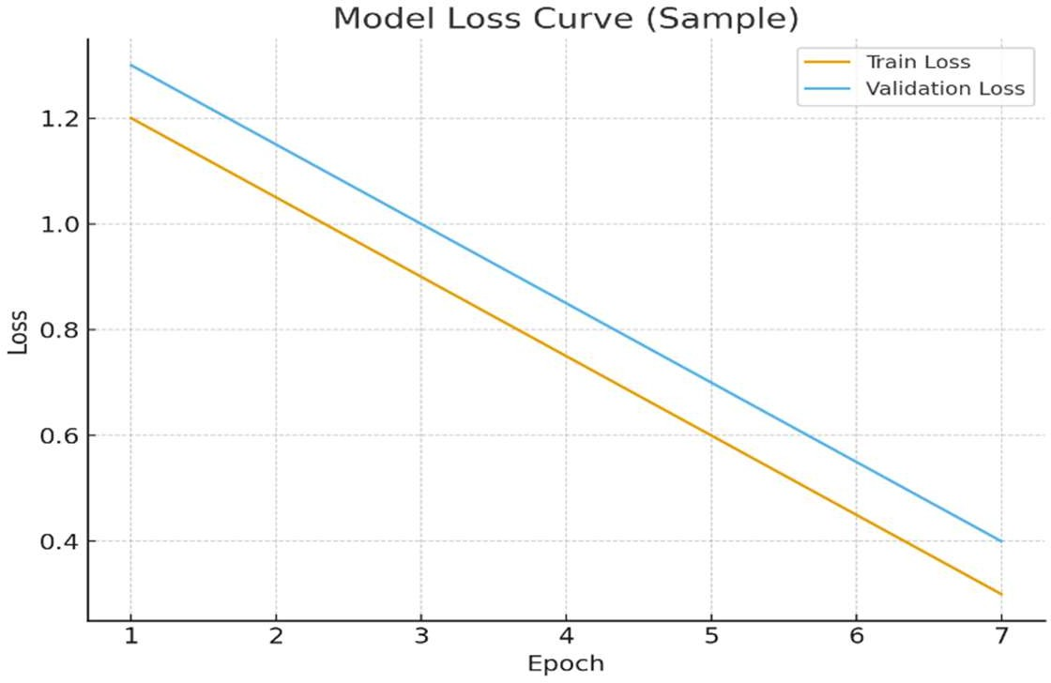

Training Accuracy Curve

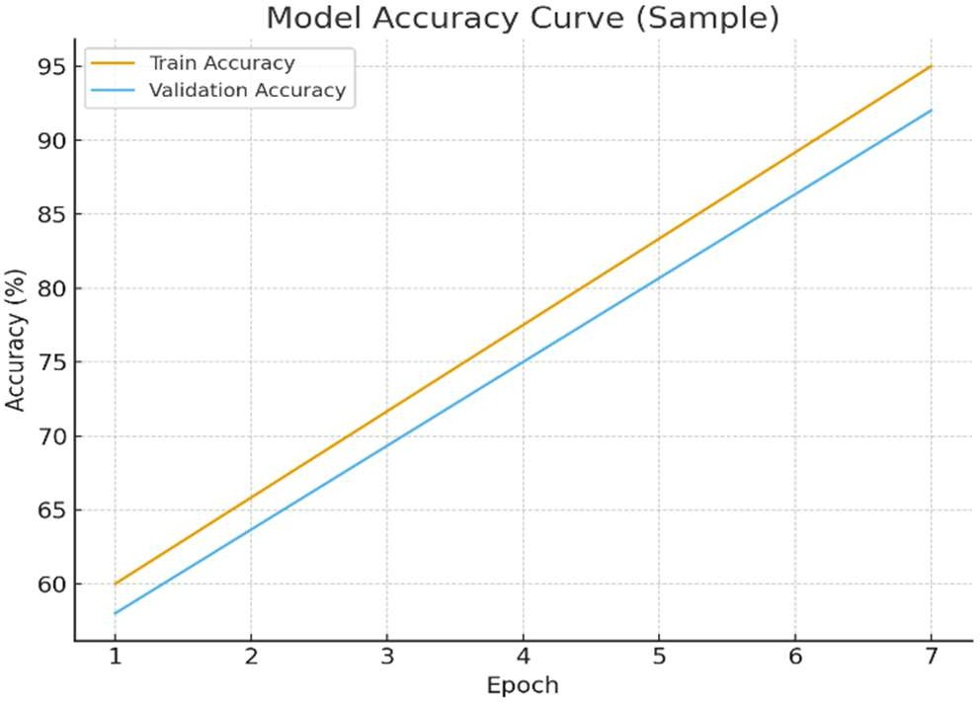

Testing Approach

- Validation dataset used for unbiased evaluation.
- Accuracy and loss monitored across epochs.
- External MRI scans tested for prediction reliability.
- Possible comparison with baseline models.

Challenges Faced
- Limited dataset variety.
- Variation in MRI brightness/quality.
- GPU limitations slowed training.
- Hyperparameter tuning required multiple attempts.

Learnings & Key Takeaways
- Hands-on understanding of CNN architecture.
- Practical experience with PyTorch training loop.
- Importance of preprocessing and augmentation.
- Insight into model optimization strategies.

Future Enhancements
- ADD tumor segmentation (U-Net).
- Deploy as a web/mobile application.
- Expand dataset for multi-class tumor detection.
- Integrate real-time MRI imaging support.

References
- PyTorch Official Documentation
- Kaggle Brain MRI Dataset
- Research articles on CNNs in medical imaging

